🧾 Chapter 1: Introduction to Databricks (Revision Notes)

🔹 What is Databricks?
Databricks = Cloud-based unified analytics platform built on Apache Spark
✅ Key Capabilities:
- Data Engineering
- Data Science
- Machine Learning
- Data Analytics
✅ Core Idea:
👉 One platform for end-to-end data lifecycle

🔹 Key Features
- Unified Platform → Engineering + ML + Analytics
- Scalable → Auto-scaling clusters
- Collaborative → Shared notebooks
- Cloud-based → Works on AWS, Azure, GCP
- Delta Lake Support → Reliable data storage
- Security → Managed via Unity Catalog

🔹 Key Components (Important for Interviews 🔥)
1. Workspace
- Central working environment
- Contains notebooks, dashboards, libraries

2. Clusters
- Provide compute power
- Types:
  - Single-node → Learning
  - Multi-node → Production

3. Notebooks
- Interactive coding environment
- Languages:
  - Python, SQL, Scala, R
Features:
- Auto-save
- Version history
- Markdown + Code cells

4. Jobs
- Automates workflows
- Used for:
  - ETL pipelines
  - Scheduled tasks

5. Databricks Runtime
- Optimized version of Spark
- Faster than open-source Spark

6. Delta Lake
- Adds ACID properties
- Ensures:
  - Data consistency
  - Reliability

7. Unity Catalog
- Data governance layer
- Controls:
  - Access
  - Permissions
  - Security

🔹 Use Cases
- 🔄 ETL Pipelines
- 📊 Data Science & ML
- 🧮 SQL Analytics
- 🏗️ Data Lakehouse
- ⚡ Real-time Processing

🔹 Setup
- Requires cloud account (AWS/Azure/GCP)
- Alternative → Community Edition (Free)

🔹 Notebooks Creation Steps
- Click New → Notebook
- Enter name
- Choose language
- Start coding

🔹 Cluster (Important Concept)
- Executes your code
- Distributed processing
- For learning → Single-node cluster

📘 Chapter 2: Getting Started with Databricks

🔹 DBFS (Databricks File System)
📂 Definition:
- Distributed file system in Databricks
- Built on cloud storage

🔹 Key Features
- Unified interface (like local system)
- Persistent storage
- Scalable (cloud-based)
- Unix-like structure
- Integrated with notebooks

🔹 Access DBFS
dbfs:/FileStore/tables/

🔹 Use Cases
- Data storage
- File sharing
- Backup
- Data ingestion

🔹 Limitation
- Cannot access outside Databricks

🔹 Absolute vs Relative Path
📌 Absolute Path
- Full path from root
👉 Example:
dbfs:/FileStore/tables/file.csv
📌 Relative Path
- Based on current directory
👉 Short & flexible

📘 Chapter 3: Read Data with Databricks

🔹 Magic Commands
%fs ls /FileStore/tables
- %fs → Access DBFS
- ls → List files

🔹 What is DataFrame?
A DataFrame = Distributed table (rows + columns) in Spark
✅ Features:
- Schema-defined
- Distributed processing
- Immutable
- Optimized using Spark engine

🔹 Data Sources Supported
- CSV
- JSON
- Parquet
- ORC

🔹 Read CSV File
df = spark.read.csv('/FileStore/tables/file.csv',
header=True,
inferSchema=True)
df.show()
📌 Key Parameters:
- header=True → First row = column names
- inferSchema=True → Auto data types

🔹 Read JSON File
df = spark.read.json("path")

🔹 Schema Handling
1. Auto Schema
- Automatically detects structure
2. Custom Schema (Important 🔥)
from pyspark.sql.types import *
schema = StructType([
StructField("name", StringType(), True),
StructField("age", IntegerType(), True)
])
df = spark.read.json(path, schema=schema)
✅ Benefits:
- Better performance
- More control
- Consistent data types

🔹 Useful Commands
df.show() # View data
df.printSchema() # View structure
display(df) # UI display (Databricks)

🔹 Read Parquet File
df = spark.read.parquet("path")
📌 Note:
- Faster than CSV/JSON
- Columnar format

🔹 Nested JSON (Very Important 🔥)
📌 What is Nested JSON?
- JSON inside JSON

📌 Example Structure:
{
"name": "John",
"address": {
"city": "New York"
}
}
🔹 Access Nested Fields
df.select("address.city").show()

🔹 Key Points:
- Use dot notation
- Handle arrays carefully
- Common errors:
  - Wrong path
  - Typos
✅ Final Quick Revision (1-Minute 🔥)
- Databricks = Unified Spark-based platform
- DBFS = Storage layer
- DataFrame = Distributed table
- Cluster = Compute engine
- Delta Lake = ACID reliability
- JSON/CSV/Parquet = Data sources
- Schema = Important for performance
- Nested JSON = Use dot operator
📘 Chapter 4: PySpark Transformations in Databricks

🔹 What are Transformations in PySpark?
👉 Transformations = Operations applied on a DataFrame to modify data
✅ Types:
- Narrow transformations (fast, no shuffle)
- Wide transformations (shuffle involved)

🔹 Filter & Where Transformation
📌 Purpose:
- Filter rows based on condition

✅ Methods to Filter Data
df.filter(df['customer_type'] == 'VIP')
from pyspark.sql.functions import col
df.filter(col('customer_type') == 'VIP')
df.filter(df.customer_type == 'VIP')

🔹 Multiple Conditions
df.filter((df['customer_type'] == 'VIP') & (df['country'] == 'USA'))
df.filter((df['customer_type'] == 'VIP') | (df['country'] == 'USA'))

🔹 where() Function
df.where(df['customer_type'] == 'VIP')
👉 Same as filter()

🧠 Flow (Filtering Logic)
Raw DataFrame
↓
Apply Condition
↓
Filtered DataFrame

🔹 Add / Remove Columns
📌 Add Column → withColumn()
from pyspark.sql.functions import lit
df = df.withColumn('new_column', lit(100))

📌 Derived Column
df = df.withColumn('salary', df['age'] * 1000)

📌 Conditional Column
from pyspark.sql.functions import when
df = df.withColumn('seniority',
when(df['age'] > 30, 'Senior')
.otherwise('Junior'))

🧠 Flow
Existing DataFrame
↓
Apply Logic
↓
New Column Added

🔹 Select Function
📌 Select Columns
df.select('age', 'gender', 'customer_type')

📌 Derived Columns
df.select((df['age'] * 1000).alias('salary'))

📌 Nested JSON Access
df.select('address.city', 'address.state')

🔹 Union & Distinct
📌 Combine DataFrames
df3 = df1.union(df2)

📌 Remove Duplicates
df.distinct()

📌 Distinct Columns
df.select('customer_type').distinct()

🔹 Sorting Data
📌 Ascending
df.orderBy('column_name')

📌 Descending
from pyspark.sql.functions import desc
df.orderBy(desc('column_name'))

📌 Multiple Columns
df.orderBy('col1', 'col2')

📌 Null Handling
from pyspark.sql.functions import col
df.orderBy(col('col').asc_nulls_first)

🧠 Flow
Unsorted Data
↓
Apply Sorting
↓
Sorted Data

🔹 GroupBy & Aggregation (VERY IMPORTANT 🔥)
📌 Basic GroupBy
df.groupBy('column_name')

📌 Aggregations
df.agg({'column_name': 'sum'})

📌 Multiple Aggregations
from pyspark.sql.functions import sum, avg, max, min
df.groupBy('column_name').agg(
sum('column_name').alias('Sum'),
max('column_name').alias('Max'),
avg('column_name').alias('Avg')
)

🧠 Flow
Raw Data
↓
GroupBy
↓
Aggregation
↓
Summary Data

🔹 String Manipulation
📌 Common Functions
from pyspark.sql.functions import *
- upper() → uppercase
- lower() → lowercase
- trim() → remove spaces
- ltrim() / rtrim()
- regex_replace()
- split()
- contains()
- length()
- concat()

📌 Example
df.withColumn('name_upper', upper('name'))

🔹 Date Manipulation (Important for Real Projects 🔥)
📌 Extract Date Parts
from pyspark.sql.functions import *
df.select(year('date'))
df.select(month('date'))
df.select(dayofmonth('date'))

📌 Advanced
df.select(dayofweek('date'))
df.select(weekofyear('date'))
df.select(quarter('date'))

📌 Add / Subtract Dates
df.select(date_add('date', 5))
df.select(date_sub('date', 5))

📌 Format Date
df.select(date_format('date', 'yyyy-MM-dd'))

📌 Current Date
df.select(current_date())

🧠 Flow
Date Column
↓
Apply Function
↓
Extract / Transform Date

📘 Chapter 5: Write DataFrame in Databricks

🔹 Write DataFrame to DBFS
👉 Used to save processed data

🔹 Write CSV
df.write.mode('overwrite') \
.option('header', 'true') \
.csv('path/to/save')

🔹 Write JSON
df.write.mode('overwrite').json('path')

🔹 Write Parquet (Recommended 🔥)
df.write.mode('overwrite').parquet('path')

🔹 Write Modes
Mode | Meaning
overwrite | Replace data
append | Add data
ignore | Skip if exists
error | Throw error

🔹 Check Files in DBFS
dbutils.fs.ls('path/to/save')

🧠 End-to-End Flow (Very Important 🔥🔥)
Raw Data (CSV/JSON)
↓
Read into DataFrame
↓
Transform (filter, select, groupBy)
↓
Clean & Process Data
↓
Write to DBFS (CSV/Parquet)

✅ Final Quick Revision (1-Minute)
- filter / where → row filtering
- withColumn → add column
- select → choose columns
- groupBy + agg → aggregation
- orderBy → sorting
- String functions → cleaning
- Date functions → time analysis
- write → save data
📘 Partitioning in Databricks

🔹 What is Partitioning?
👉 Partitioning = Splitting data into multiple folders based on column values

✅ Benefits
⚡ 1. Performance Improvement
- Reads only required partition
- Reduces full data scan
📂 2. Data Organization
- Data stored like:
country=India/
country=USA/
country=UK/

🧠 Flow
Raw Data
↓
Partition by column (e.g., country)
↓
Stored in multiple folders
↓
Faster querying

🔹 Command
df.write.mode('overwrite') \
.option('header', 'true') \
.partitionBy('column_name') \
.csv('path/to/save')

🔹 Check Output
dbutils.fs.ls('path/to/save')

📘 Chapter 6: Spark SQL in Databricks

🔹 What is Spark SQL?
👉 SQL engine on top of Apache Spark

✅ Key Features
- SQL-like syntax
- Works on structured & unstructured data
- Integrated with DataFrames
- Uses Catalyst Optimizer
- Schema enforcement

🔹 Why Use Spark SQL?
- Easy (SQL users friendly)
- Scalable (GB → TB data)
- High performance
- Flexible (SQL + PySpark mix)

🔹 Limitations
- Slight latency for small queries
- Complex logic → better with DataFrame API

🔹 Temporary Views
📌 Definition:
- Table-like structure from DataFrame

✅ Features:
- Session-based
- In-memory
- Not saved to disk
- Used for quick analysis

📌 Create Temp View
df.createOrReplaceTempView("customer_view")

🔹 Global Temporary Views
📌 Key Difference:
Feature | Temp View | Global Temp View
Scope | Session | Across sessions
Storage | Memory | Memory
Access | Direct | global_temp.view

📌 Create
df.createGlobalTempView("customer_view")

📌 Access
SELECT * FROM global_temp.customer_view

🔹 Spark SQL Transformations
📌 Run SQL
spark.sql("SELECT * FROM customer_view")

📌 Filtering
SELECT * FROM customer_view WHERE customer_type = 'regular'

📌 Aggregation
SELECT country, COUNT(*) FROM customer_view GROUP BY country

📌 DISTINCT
SELECT DISTINCT customer_type FROM customer_view

🧠 Flow
DataFrame
↓
Create View
↓
SQL Query
↓
Result DataFrame

🔹 Managed vs External Tables

📌 Managed Table
- Data + metadata managed by Databricks
- Deleting table → deletes data
df.write.saveAsTable("table_name")

📌 External Table
- Only metadata managed
- Data stored externally (S3/ADLS/DBFS)

✅ Features:
- Data safety
- Shared access
- Independent storage

📌 Create External Table
df.write.mode('overwrite') \
.option('path', 'external_path') \
.saveAsTable('customer_ext_table')

📘 Chapter 7: Delta Lake

🔹 What is Delta Lake?
👉 Storage layer with ACID transactions

✅ Use Cases
- ETL pipelines
- Real-time processing
- Data warehouse
- Lakehouse
- Machine learning

🔹 Create Delta Table
df.write.mode('overwrite') \
.format('delta') \
.saveAsTable('customer_delta')

🔹 DML Operations
📌 Insert
INSERT INTO customer_delta VALUES (...)
📌 Update
UPDATE customer_delta
SET customer_type = 'Regular'
WHERE customer_id = 1001
📌 Delete
DELETE FROM customer_delta
WHERE customer_id = 1001

🔹 Time Travel (VERY IMPORTANT 🔥🔥)
📌 View History
DESCRIBE HISTORY customer_delta

📌 Access Old Version
SELECT * FROM customer_delta VERSION AS OF 1

📌 Restore
RESTORE customer_delta TO VERSION AS OF 1

🧠 Flow
Data Changes
↓
Version Created
↓
Query old version
↓
Restore if needed

📘 Chapter 8: Join Optimization

🔹 Types of Joins
- Inner Join
- Left Join
- Right Join
- Full Join

🔹 Join Example
df1.join(df2, df1.id == df2.id, 'inner')

🔹 Broadcast Join (VERY IMPORTANT 🔥)
📌 Concept:
- Small table sent to all nodes

✅ Benefits:
- No shuffle
- Faster joins

📌 Example
from pyspark.sql.functions import broadcast
df1.join(broadcast(df2), "id")

⚠️ Limitation:
- Small table must fit in memory

🔹 Bucketing
📌 Concept:
- Divide data into fixed buckets

📌 Benefits:
- Faster joins
- Reduced shuffle

📌 Command
df.write.format('parquet') \
.bucketBy(4, 'customer_id') \
.saveAsTable('customer_bucket')

⚠️ Limitations:
- Fixed bucket size
- Initial overhead

📘 Chapter 10: Cluster Management

🔹 What is Cluster?
👉 Compute engine to run code

🔹 Interactive Cluster
✅ Features:
- Used for development
- Shared across users
- Persistent state
- Manual control

⚠️ Cost Tip:
- Use auto-termination

🧠 Flow
Create Cluster
↓
Attach Notebook
↓
Run Code

📘 Chapter 11: Workflows

🔹 Job Cluster
✅ Features:
- Runs specific job
- Auto start & stop
- Isolated environment

🔹 Interactive vs Job Cluster
Feature | Interactive | Job
Usage | Dev | Production
State | Persistent | Temporary
Sharing | Yes | No

🔹 Create Workflow
Steps:
- Go to Workflows
- Create Job
- Add Task
- Select Notebook
- Configure cluster
- Set schedule
- Run

🧠 Flow
Notebook Tasks
↓
Workflow
↓
Scheduled Execution

📘 Chapter 12: dbutils in Databricks

🔹 What is dbutils?
👉 Built-in utility for managing:
- Files
- Notebooks
- Secrets

🔹 Key Features
- File operations
- Notebook chaining
- Secret management
- Widgets (UI inputs)

🔹 Commands
📌 Help
dbutils.help()
dbutils.fs.help()

📌 File Operations
dbutils.fs.mkdirs('/path')
dbutils.fs.ls('/path')
dbutils.fs.cp('src', 'dest')
dbutils.fs.rm('path')
dbutils.fs.mv('src', 'dest')

📌 Magic Commands
%fs ls /FileStore/tables

🧠 Flow
User Command
↓
dbutils
↓
DBFS Operation

✅ Final Quick Revision (Super Important 🔥)
- Partitioning → performance optimization
- Spark SQL → SQL on Spark
- Temp Views → session-based
- Delta Lake → ACID + time travel
- Broadcast Join → fast joins
- Bucketing → reduce shuffle
- Cluster → compute
- Workflow → automation
- dbutils → file + utility tool
+++++++++++++++++++++++++++++++++++++++++++++++++++++++++++++++++++
Detailed notes on delta lake
🔹 1. What is Delta Lake?
✅ Definition
Delta Lake is a storage layer on top of data lakes that brings:
- Reliability
- Performance
- Data consistency
👉 Built on top of Parquet files

🔹 Why Delta Lake?
Traditional Data Lakes problems:
- ❌ No ACID transactions
- ❌ Data inconsistency
- ❌ Difficult updates/deletes
- ❌ Poor performance
👉 Delta Lake solves all of these ✅

🔹 2. Delta Lake Architecture (VERY IMPORTANT)
🔁 Flow
Data → Delta Table → Parquet Files + Transaction Log (_delta_log)

🔹 Core Components
1. Data Files
- Stored as Parquet
2. Transaction Log (_delta_log)
- Stores:
  - All operations (INSERT, UPDATE, DELETE)
  - Metadata
  - Version history
👉 This is the brain of Delta Lake

🔹 3. ACID Transactions (MOST IMPORTANT)
Property | Meaning
Atomicity | All or nothing
Consistency | Valid data always
Isolation | No conflict
Durability | Data never lost
👉 Ensures reliable data operations

🔹 4. Creating Delta Tables
✅ From DataFrame
df.write.format("delta").saveAsTable("table_name")
✅ External Table
df.write.format("delta").option("path", "path").saveAsTable("table_name")

🔹 Managed vs External
Feature | Managed | External
Storage | Databricks | External
Delete | Data deleted | Data remains

🔹 5. DML Operations (VERY IMPORTANT)
✅ Supported Operations
INSERT INTO table
UPDATE table SET col = value WHERE condition
DELETE FROM table WHERE condition
MERGE INTO table

🔹 MERGE (UPSERT)
👉 Used for:
- Insert + Update together
MERGE INTO target t
USING source s
ON t.id = s.id
WHEN MATCHED THEN UPDATE
WHEN NOT MATCHED THEN INSERT

🔹 6. Time Travel & Versioning (🔥 HIGH PRIORITY)
✅ What is Time Travel?
Access old versions of data

🔹 Commands
SELECT * FROM table VERSION AS OF 1
SELECT * FROM table TIMESTAMP AS OF '2024-01-01'
DESCRIBE HISTORY table

🔹 Restore Table
RESTORE TABLE table TO VERSION AS OF 1

🔹 Important Notes
- Every change creates a new version
- Stored in _delta_log

🔹 7. VACUUM (IMPORTANT)
✅ Purpose
- Deletes old files
- Frees storage
VACUUM table

🔹 Key Points
- Default retention = 7 days
- Removes old versions
⚠️ After VACUUM:
👉 Time travel may NOT work

🔹 8. Schema Management

🔸 Schema Enforcement
- Prevents invalid data
- Example: string → int ❌

🔸 Schema Evolution
.option("mergeSchema", "true")
👉 Allows:
- Adding new columns

🔸 overwriteSchema
- Replaces entire schema

🔹 Key Difference
Feature | Enforcement | Evolution
Behavior | Strict | Flexible

🔹 9. Performance Optimization (VERY IMPORTANT)

🔸 Partitioning
df.write.partitionBy("country")
Use When:
- Column has low cardinality

🔸 Small File Problem
- Many small files → slow performance

🔸 OPTIMIZE
OPTIMIZE table
👉 Combines small files

🔸 Z-Ordering
OPTIMIZE table ZORDER BY (column)
👉 Improves filtering performance

🔹 Partition vs Z-Order
Feature | Partition | Z-Order
Based on | Folder | Data clustering
Use case | Large filtering | Multiple columns

🔸 Data Skipping
- Reads only relevant data
- Improves speed

🔹 10. Streaming with Delta

✅ Supports both:
- Batch
- Streaming

🔸 Example
df.writeStream.format("delta")

🔹 Key Concepts
Concept | Meaning
Checkpoint | Tracks progress
Exactly-once | No duplicates
Micro-batch | Small chunks

🔹 11. Delta Internals (EXAM TRICKY)

🔸 _delta_log
- Stores:
  - JSON logs
  - Checkpoints
  - Versions

🔸 Checkpointing
- Combines logs for performance

🔸 Versioning
- Each commit = new version

🔹 12. Delta vs Parquet (VERY IMPORTANT)
Feature | Delta | Parquet
ACID | ✅ | ❌
Time Travel | ✅ | ❌
Update/Delete | ✅ | ❌
Performance | Better | Good

🔹 13. Common Exam Scenarios (🔥 MUST KNOW)

💡 Scenario 1
👉 Need UPSERT →
✅ Use MERGE

💡 Scenario 2
👉 Recover deleted data →
✅ Use Time Travel / RESTORE

💡 Scenario 3
👉 Too many small files →
✅ Use OPTIMIZE

💡 Scenario 4
👉 Faster filtering →
✅ Use Z-ORDER

💡 Scenario 5
👉 Schema changed →
✅ Use mergeSchema

💡 Scenario 6
👉 Remove old data →
✅ Use VACUUM

🔥 FINAL REVISION (1-MINUTE MEMORY)
👉 Remember this flow:
Delta = Parquet + Transaction Log
👉 Key Features:
- ACID
- Time Travel
- Schema Enforcement
- DML Support
👉 Optimization:
- Partition
- Optimize
- Z-Order
👉 Recovery:
- Versioning
- Restore
####### Question ##################################################
🔹 Section 1: Basics (1–20)
- What is Delta Lake?
- Which problem does Delta Lake solve in data lakes?
- What file format does Delta Lake use internally?
- What is a Delta table?
- What is the purpose of transaction logs?
- What is _delta_log folder?
- What is ACID in Delta Lake?
- What is Atomicity?
- What is Consistency?
- What is Isolation?
- What is Durability?
- Difference between Delta Lake and Parquet?
- Can Delta Lake work on cloud storage?
- What is schema enforcement?
- What is schema evolution?
- Can Delta Lake handle streaming data?
- What is data versioning?
- What is time travel?
- What is the default format of Delta tables?
- What is a managed Delta table?

🔹 Section 2: Table Creation & Operations (21–40)
- How do you create a Delta table from DataFrame?
- How do you convert Parquet to Delta?
- What is format("delta")?
- What is saveAsTable()?
- What happens when overwrite mode is used?
- Difference between append and overwrite?
- What is MERGE INTO in Delta?
- How do you perform UPSERT in Delta?
- Can Delta Lake handle DELETE operations?
- Can Delta Lake handle UPDATE operations?
- What is INSERT INTO?
- What is VACUUM?
- Why VACUUM is used?
- Default retention period for VACUUM?
- What happens if retention period is reduced?
- How to drop a Delta table?
- What happens to data when dropping managed table?
- What happens to external table data?
- What is OPTIMIZE?
- What is Z-Ordering?

🔹 Section 3: Time Travel & Versioning (41–55)
- What is time travel in Delta Lake?
- How to query old version of table?
- What is VERSION AS OF?
- What is TIMESTAMP AS OF?
- What is DESCRIBE HISTORY?
- Can you restore old data?
- What is RESTORE command?
- How many versions Delta keeps?
- What happens after VACUUM?
- Can time travel work after VACUUM?
- What is commit history?
- What metadata is stored in history?
- What is version number?
- What is checkpointing in Delta?
- Why checkpoint is used?

🔹 Section 4: Schema & Data Quality (56–70)
- What is schema enforcement?
- What happens if schema mismatch occurs?
- How to enable schema evolution?
- What is mergeSchema option?
- What is overwriteSchema?
- Difference between enforcement and evolution?
- What is data consistency?
- Can you add columns dynamically?
- Can you remove columns?
- What is nullable field?
- What is data validation?
- What happens if wrong datatype is inserted?
- Can Delta reject bad data?
- What is constraint enforcement?
- What is NOT NULL constraint?

🔹 Section 5: Performance Optimization (71–85)
- What is data skipping?
- How does Delta improve read performance?
- What is partitioning in Delta?
- When to use partitioning?
- What is small file problem?
- How to fix small file issue?
- What is OPTIMIZE command?
- What is ZORDER BY?
- Difference between partitioning and Z-order?
- What is file compaction?
- What is caching in Delta?
- Does Delta support indexing?
- What is column pruning?
- What is predicate pushdown?
- What is lazy evaluation?

🔹 Section 6: Streaming + Delta (86–95)
- Can Delta support streaming?
- What is structured streaming?
- What is checkpoint location?
- Why checkpoint is required?
- What is exactly-once processing?
- What is micro-batch processing?
- Can batch and streaming use same table?
- What is sink in streaming?
- What is trigger in streaming?
- What is watermarking?

🔹 Section 7: Scenario-Based (96–100)
- You need to update existing records → which command?
- You want to recover deleted data → what to use?
- Your table has too many small files → solution?
- You need faster filtering on large data → use what?
- You accidentally overwrote data → how to recover?
+++++++++++++++++++++++++ Unity catalog notes ++++++++++++++++++++++
🔹 1. What is Unity Catalog?
Unity Catalog is Databricks’ centralized data governance solution used to manage:
- Data access (who can see/use data)
- Security policies
- Metadata (tables, schemas, etc.)
- Auditing and compliance
👉 It provides fine-grained access control across all Databricks workspaces.

🔹 2. Why Unity Catalog is Important
⭐ Key Benefits
- Centralized Governance
  - Manage permissions from one place across multiple workspaces
- Fine-Grained Access Control
  - Control access at:
    - Catalog level
    - Schema level
    - Table level
    - Column level
    - Row level (advanced)
- Data Lineage
  - Track where data comes from and how it is transformed
- Security & Compliance
  - Helps meet regulatory requirements
- Multi-Workspace Support
  - One catalog can serve multiple workspaces

🔹 3. Unity Catalog Architecture
📊 Hierarchy Structure
Metastore
↓
Catalog
↓
Schema (Database)
↓
Tables / Views / Functions
🧠 Explanation
- Metastore
  - Top-level container
  - Stores metadata & permissions
- Catalog
  - Logical grouping of schemas
  - Example: sales_catalog
- Schema (Database)
  - Contains tables/views
  - Example: customer_data
- Tables / Views
  - Actual data storage objects

🔹 4. Key Components
🧩 1. Metastore
- Central metadata repository
- One metastore per region (generally)
- Connected to multiple workspaces

🧩 2. Catalog
- First-level container under metastore
- Used to organize data domains
👉 Example:
CREATE CATALOG finance;

🧩 3. Schema (Database)
- Organizes tables within a catalog
👉 Example:
CREATE SCHEMA finance.customers;

🧩 4. Tables
- Managed or external
👉 Example:
CREATE TABLE finance.customers.customer_info (
id INT,
name STRING
);

🧩 5. Views
- Virtual tables based on queries

🧩 6. Functions
- Reusable logic

🔹 5. Managed vs External Tables (Important for Exam ⚠️)
🟢 Managed Table
- Data stored in Databricks-managed location
- Dropping table → deletes data
CREATE TABLE my_table (...);

🔵 External Table
- Data stored externally (e.g., S3, ADLS)
- Dropping table → does NOT delete data
CREATE TABLE my_table
USING DELTA
LOCATION 's3://bucket/path';

🔹 6. Access Control in Unity Catalog
🔐 Types of Permissions
Permission | Meaning
SELECT | Read data
INSERT | Add data
UPDATE | Modify data
DELETE | Remove data
USAGE | Access catalog/schema
CREATE | Create objects

👥 Example Grant
GRANT SELECT ON TABLE finance.customers TO user1;

🧠 Important Concept
👉 To access a table:
- User must have:
  - USAGE on catalog
  - USAGE on schema
  - SELECT on table

🔹 7. Row-Level & Column-Level Security
📌 Column-Level Security
Restrict access to specific columns
GRANT SELECT (name) ON TABLE customers TO user1;

📌 Row-Level Security
- Implemented using views or filters

🔹 8. Data Lineage (Very Important ⭐)
Unity Catalog tracks:
- Source tables
- Transformations
- Downstream usage
👉 Helps in:
- Debugging
- Impact analysis
- Compliance

🔹 9. Unity Catalog vs Hive Metastore
Feature | Unity Catalog | Hive Metastore
Governance | Centralized | Limited
Security | Fine-grained | Basic
Multi-workspace | Yes | No
Data lineage | Yes | No
Recommended | ✅ Yes | ❌ No

🔹 10. External Locations & Storage Credentials
📌 Storage Credential
- Authentication to cloud storage
CREATE STORAGE CREDENTIAL my_cred
WITH AZURE_MANAGED_IDENTITY;

📌 External Location
- Maps storage path
CREATE EXTERNAL LOCATION my_location
URL 's3://bucket/path'
WITH STORAGE CREDENTIAL my_cred;

🔹 11. Best Practices (Exam + Real Life)
- Use Unity Catalog over Hive Metastore
- Always assign least privilege access
- Use external tables for shared data
- Use catalogs for domain separation
- Enable data lineage tracking
- Use role-based access (groups) instead of individual users

🔹 12. Common Exam Traps ⚠️
- ❌ Forgetting USAGE permission
- ❌ Confusing managed vs external tables
- ❌ Thinking dropping external table deletes data
- ❌ Not understanding hierarchy (catalog → schema → table)
- ❌ Assuming Unity Catalog = DBFS (they are different)

🔹 13. Quick Revision Cheatsheet 🧾
- Unity Catalog = Governance Layer
- Structure = Metastore → Catalog → Schema → Table
- External Table = Data NOT deleted
- Managed Table = Data deleted
- Need USAGE + SELECT to query
- Supports:
  - Row-level security
  - Column-level security
  - Data lineage

🔥 Final Tip for Exam
If a question is about:
- Security → Unity Catalog
- Fine-grained access → Unity Catalog
- Multi-workspace governance → Unity Catalog
👉 90% chance answer = Unity Catalog
++++++++++++++++++++++++++++++++++++++++++++++++++
🚀 COMPLETE EXAM NOTES (100% COVERAGE)
(Unity Catalog + Delta Lake + SQL + DLT + Architecture + MCQ Mapping)

🧱 1. LAKEHOUSE ARCHITECTURE (VERY IMPORTANT)
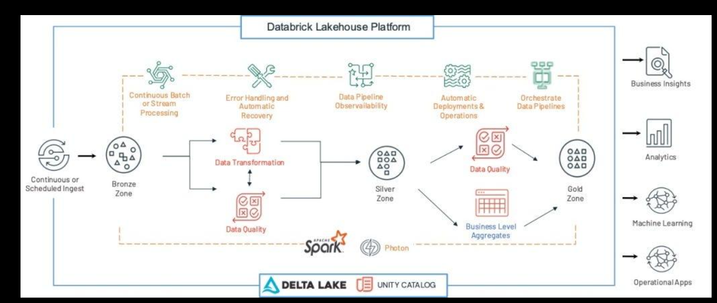
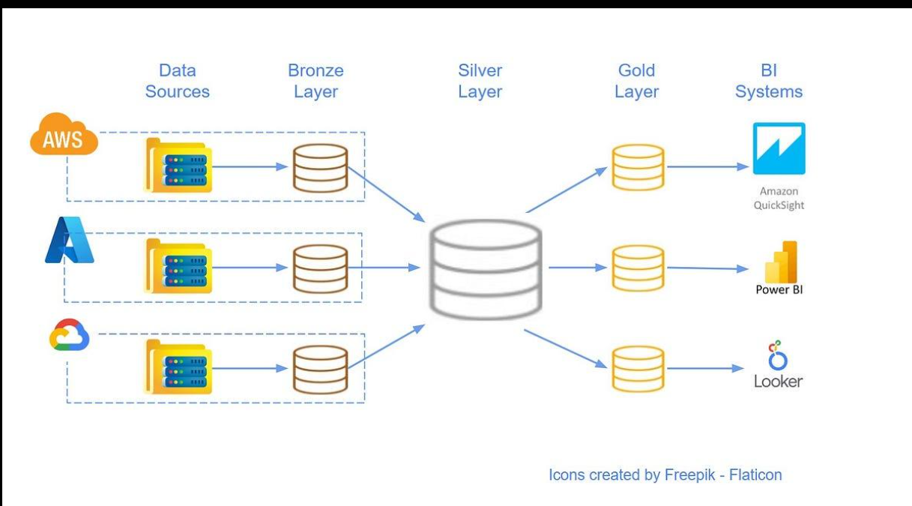
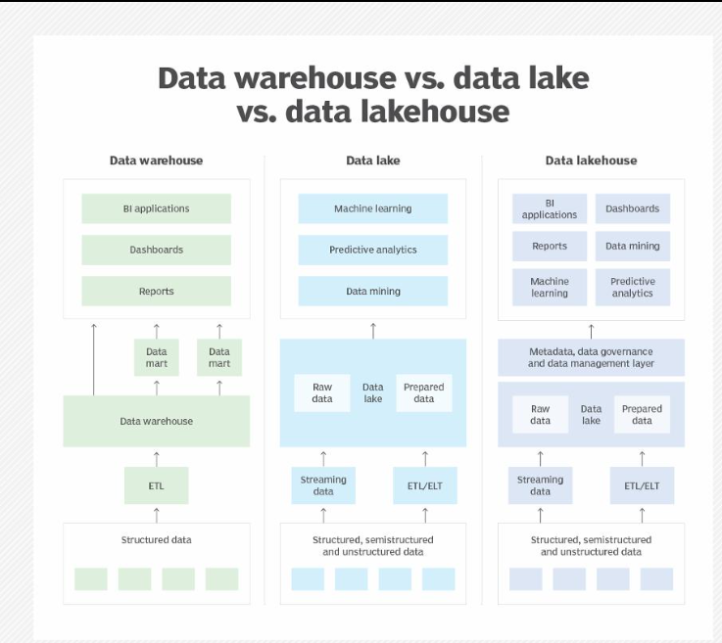
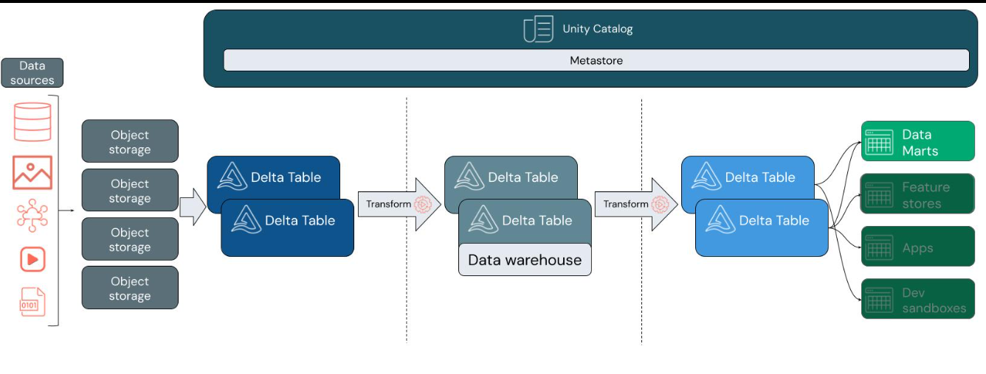
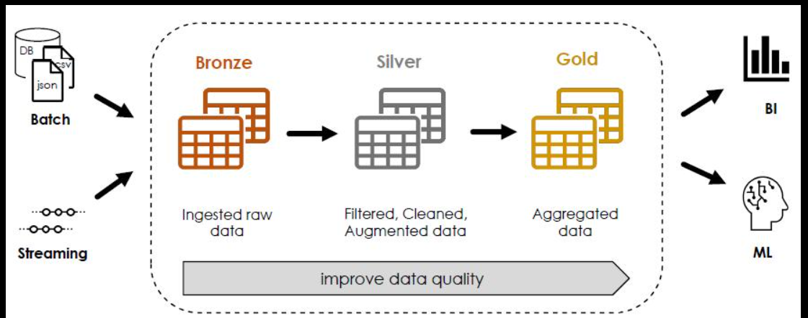
🔹 Multi-hop Architecture
- Bronze → Raw data (CSV, JSON, Kafka, logs)
- Silver → Cleaned, validated data
- Gold → Aggregated, business-ready data
🎯 Exam Mapping
- Aggregations → Gold layer
- Raw ingestion → Bronze
- Cleaned joins → Silver
⚠️ Trap
❌ Silver is NOT aggregated
❌ Gold is NOT raw

📊 2. DELTA LAKE (CORE OF EXAM)
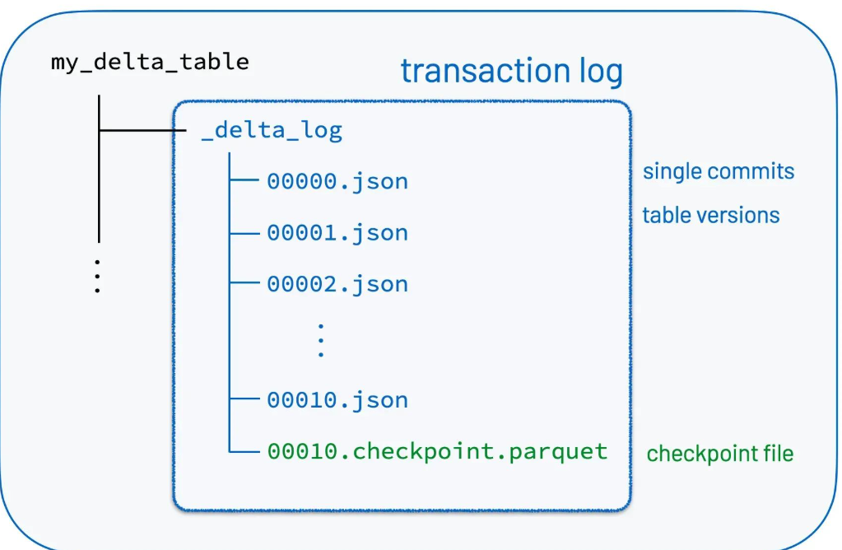
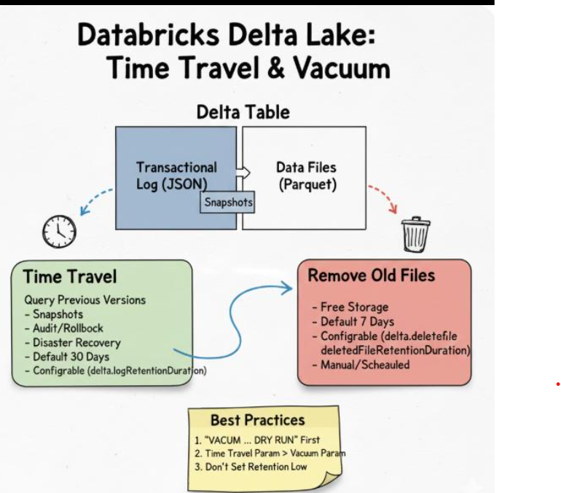
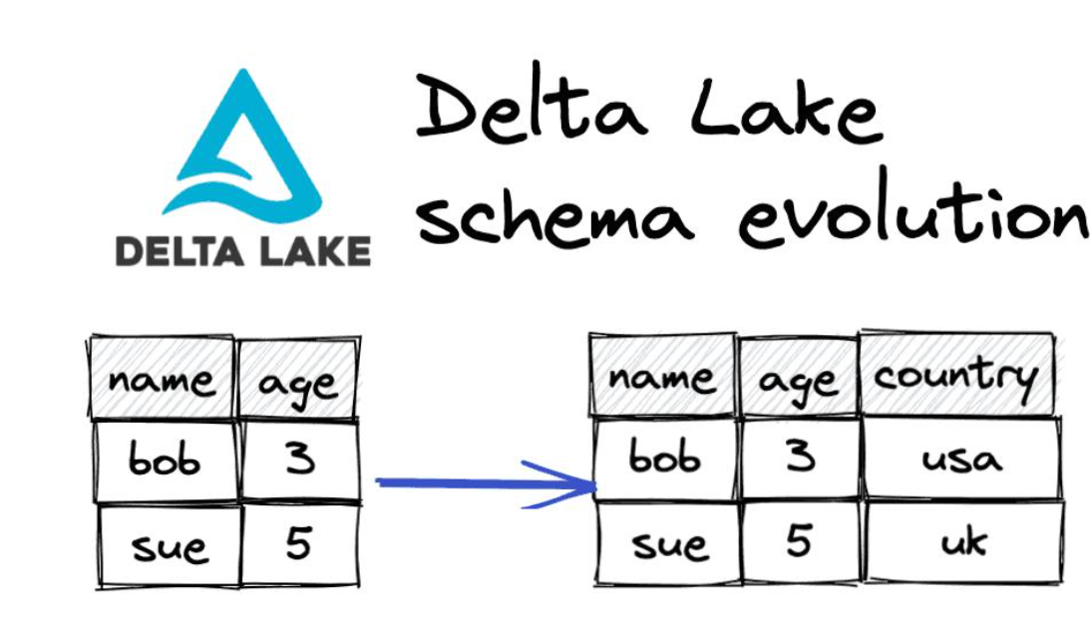
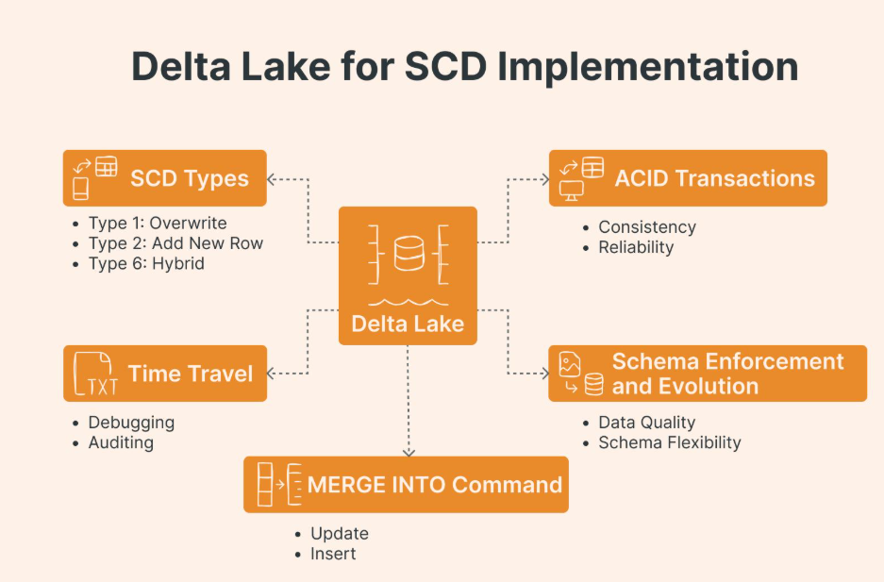
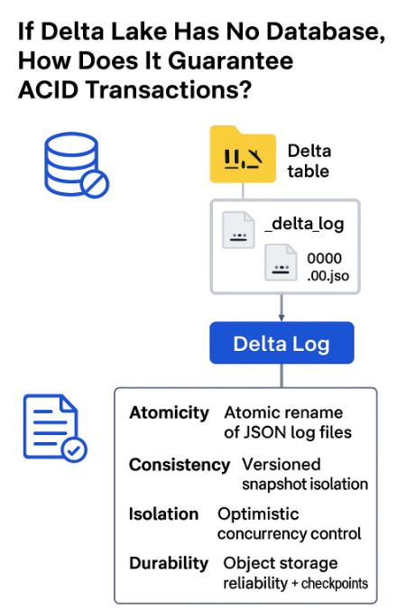

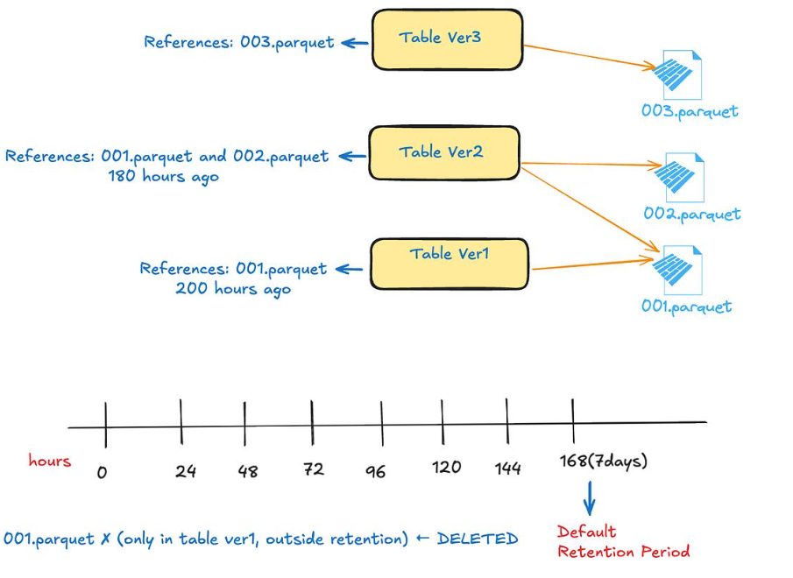

🔹 Key Features
- ACID Transactions
- Time Travel
- Schema Enforcement
- Schema Evolution
🔹 Important Commands
✅ Create Delta Table
CREATE TABLE customers (
id INT,
name STRING
) USING DELTA;
✅ Write Data
df.write.format("delta").saveAsTable("customers")
✅ DML Operations
INSERT INTO table VALUES (...)
UPDATE table SET col = value WHERE condition
DELETE FROM table WHERE condition
✅ MERGE (VERY IMPORTANT)
MERGE INTO target t
USING source s
ON t.id = s.id
WHEN MATCHED THEN UPDATE SET *
WHEN NOT MATCHED THEN INSERT *

🔹 Time Travel
SELECT * FROM table VERSION AS OF 2
SELECT * FROM table TIMESTAMP AS OF '2023-01-01'

🔹 VACUUM (VERY IMPORTANT TRAP)
VACUUM table RETAIN 48 HOURS
❗ Exam Trap:
- ❌ NOT days
- ✅ ONLY HOURS

🎯 MCQ Mapping
- Version history → Time Travel
- Delete old files → VACUUM
- Upsert → MERGE

🔐 3. UNITY CATALOG (VERY VERY IMPORTANT)
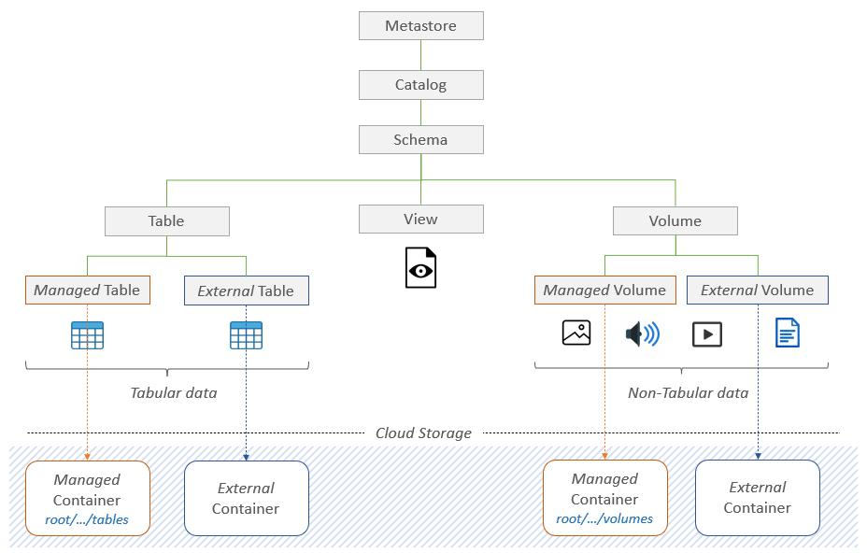
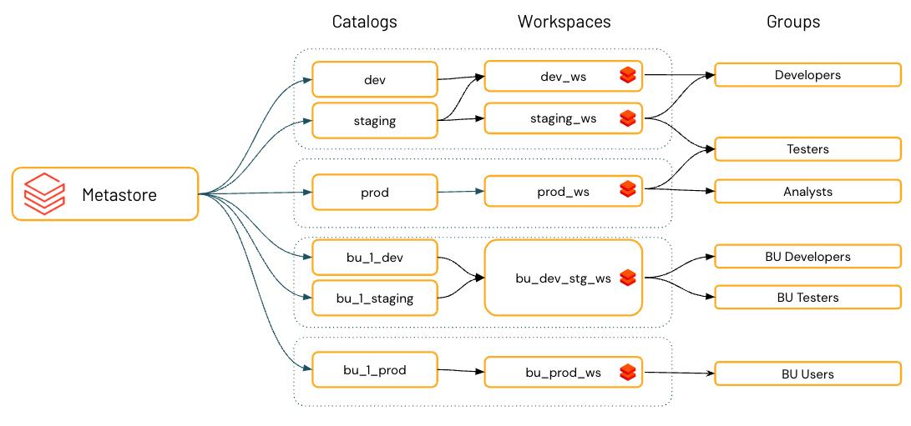
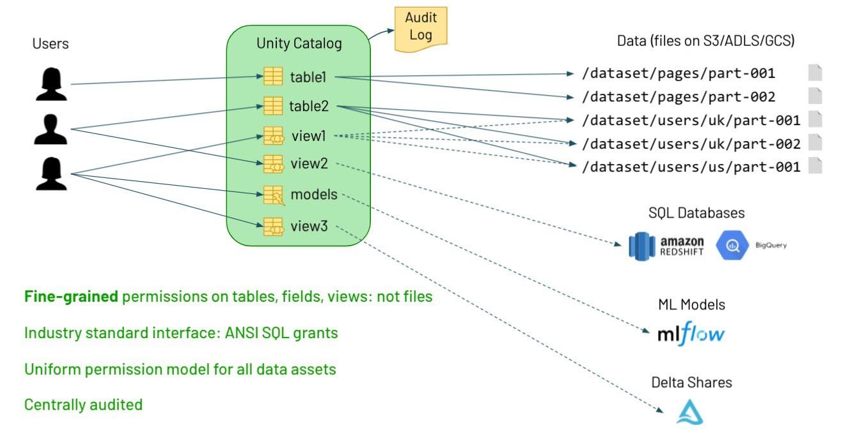

🔹 Hierarchy
Catalog → Schema → Table
🔹 Example
catalog.sales_db.customers

🔹 Key Features
- Centralized governance
- Fine-grained access control
- Audit logs
- Data lineage

🔹 Permissions
✅ Grant
GRANT SELECT ON TABLE table TO user
✅ Revoke
REVOKE SELECT ON DATABASE db FROM user

🎯 MCQ Mapping
- Fine-grained security → Unity Catalog
- Who accessed data → Audit logs
- Permissions → GRANT / REVOKE

🧠 4. SPARK SQL + DATAFRAME
🔹 DataFrame vs SQL
- SQL → Easier for analysts
- DataFrame → More control

🔹 Important Functions
Filter
df.filter(df.age > 30)
df.where(df.age > 30)
Select
df.select("name", "age")
Add Column
df.withColumn("salary", df.age * 1000)
GroupBy
df.groupBy("country").count()

🔹 SQL Queries
SELECT * FROM table
WHERE age > 30
GROUP BY country

⚠️ Exam Trap
❌ spark.sql() alone won’t show output
✅ use:
display(spark.sql("SELECT * FROM table"))

🪟 5. VIEWS (FREQUENT MCQ)
🔹 Temporary View
df.createOrReplaceTempView("temp_view")
- Session only

🔹 Global Temp View
df.createGlobalTempView("view")
Access:
SELECT * FROM global_temp.view

🎯 MCQ Mapping
- Session only → Temp View
- Cross session → Global Temp View

🧩 6. TABLE TYPES
🔹 Managed Table
- Data stored inside Databricks
- Dropped → data deleted
🔹 External Table
- Data stored externally
- Dropped → only metadata deleted

⚠️ Exam Trap
❌ External table WITHOUT location → wrong
✅ Must have location

🔄 7. AUTO LOADER
🔹 Command
spark.readStream.format("cloudFiles")

🔹 Features
- Incremental ingestion
- Schema evolution
- Works with cloud storage

🎯 MCQ Mapping
- Streaming ingestion → Auto Loader
- New column → schema evolution

⚙️ 8. DLT (DELTA LIVE TABLES)
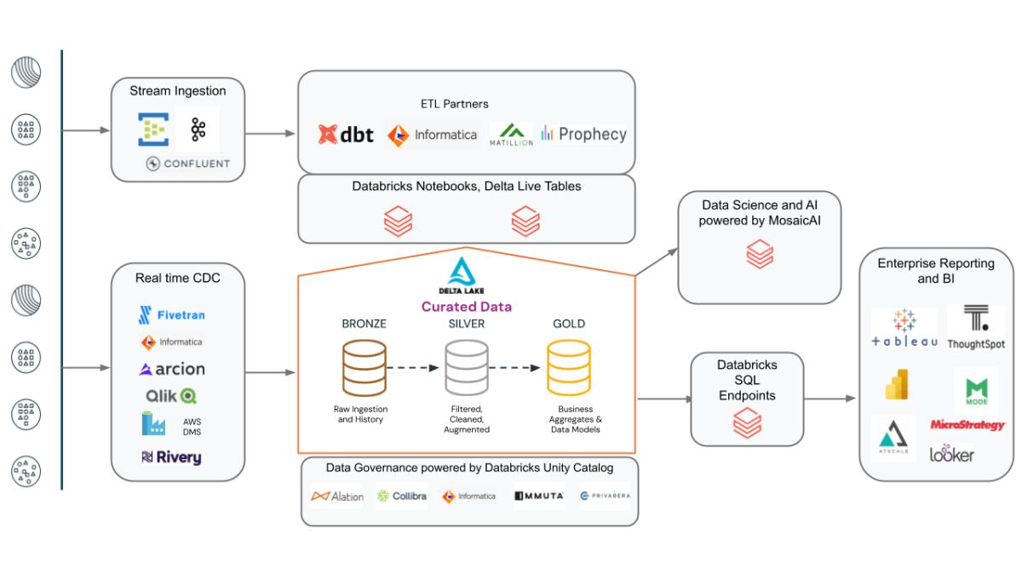
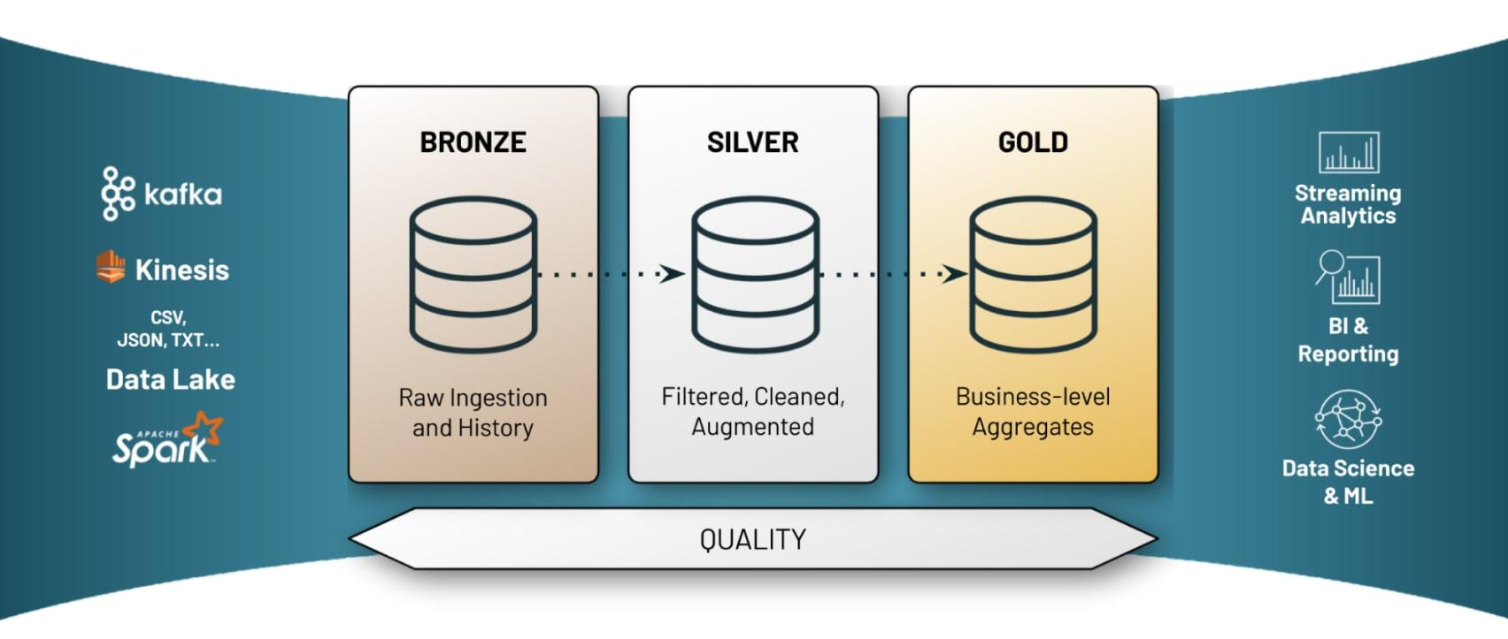
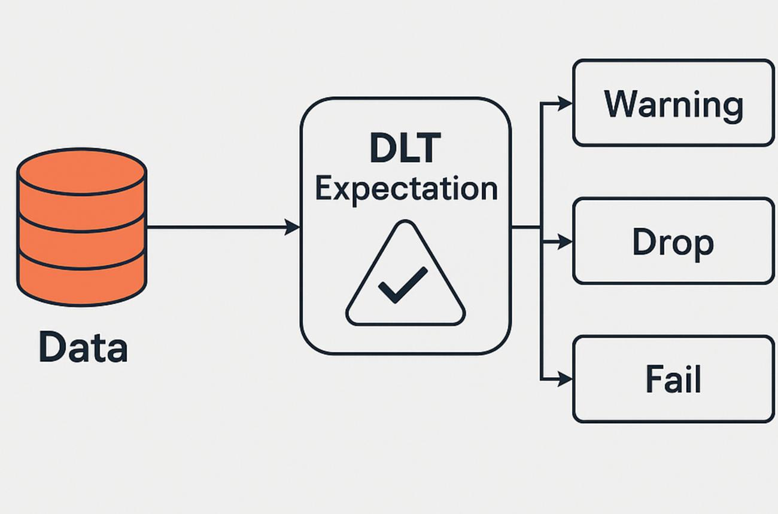
7
🔹 Features
- ETL pipelines
- Data quality checks
- Auto dependency management

🔹 Constraint Example
CONSTRAINT age_check EXPECT (age < 60)
ON VIOLATION DROP ROW

🎯 MCQ Mapping
- Drop bad data → DROP ROW
- Validation → EXPECT

🔗 9. JOINS + OPTIMIZATION
🔹 Types
- Inner
- Left
- Right
- Full

🔹 Broadcast Join
df1.join(broadcast(df2), "id")
✔ Use when one table is small

🔹 Bucketing
df.write.bucketBy(4, "id").saveAsTable("table")
✔ Improves joins

🧮 10. WORKFLOWS + CLUSTERS
🔹 Job Cluster
- Created per job
- Terminates after run ✅
🔹 Interactive Cluster
- Used for development
- Shared

🎯 MCQ Mapping
- Auto terminate → Job cluster
- Shared → Interactive

📁 11. DBUTILS
dbutils.fs.ls()
dbutils.fs.cp()
dbutils.fs.rm()

🔹 Run Notebook
%run /path/notebook

⚠️ 12. MOST IMPORTANT EXAM TRAPS
🔥 These are directly from your questions:
- VACUUM → hours only
- %run → correct command
- display() → required for output
- Job cluster → terminates
- External table → has location
- CREATE TABLE → keyword required
- Data Lake → schema NOT required

🧠 FINAL STRATEGY
✔ Focus Areas (80% exam)
- Delta Lake (VERY IMPORTANT)
- Unity Catalog (VERY IMPORTANT)
- SQL vs DataFrame
- DLT + Auto Loader
- Clusters + Workflows

